Tutorial-3

Modulus name:Amazon login
Test case id:Shital_jogi_792
Environment information:os:macos(Sequoria 15.5)system : laptop(macbook air)webpage URL:https://www.amazon.in/
Screenshort:
Scenario 1:

Demo login page:login to amazon account
Test Steps:1a
1.open the amazon website
2.login the amazon account

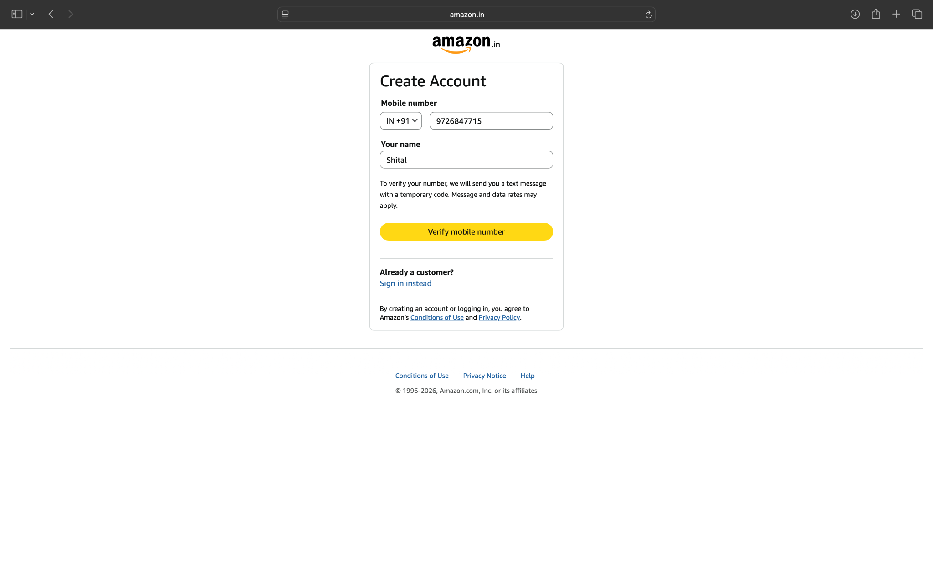

Scenario 1:

Demo login page:login to invalid amazon account
Test Steps:1b
1.Enter mobile number
2.Inavlid OTP
3.click login

Scenario 1:

Demo login page:amazon product view
Test Steps:1c
1.amazon product view
2.select product and view
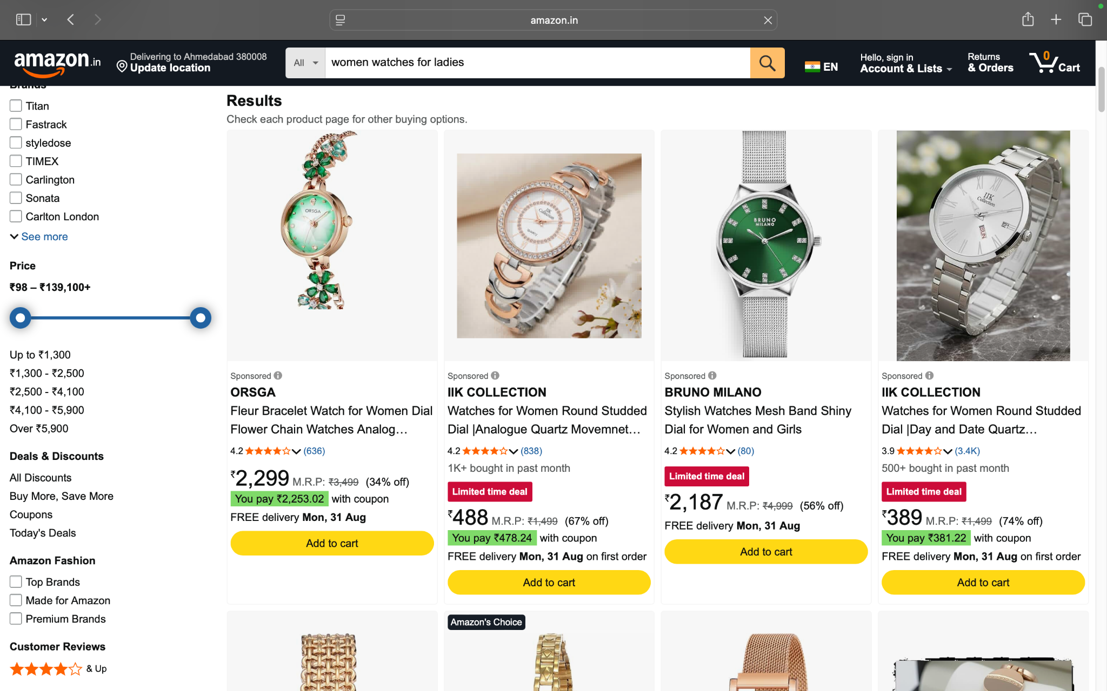

Scenario 1:

Demo login page:amazon product view and select product
Test Steps:1d
1.amazon product view
2.select product and view
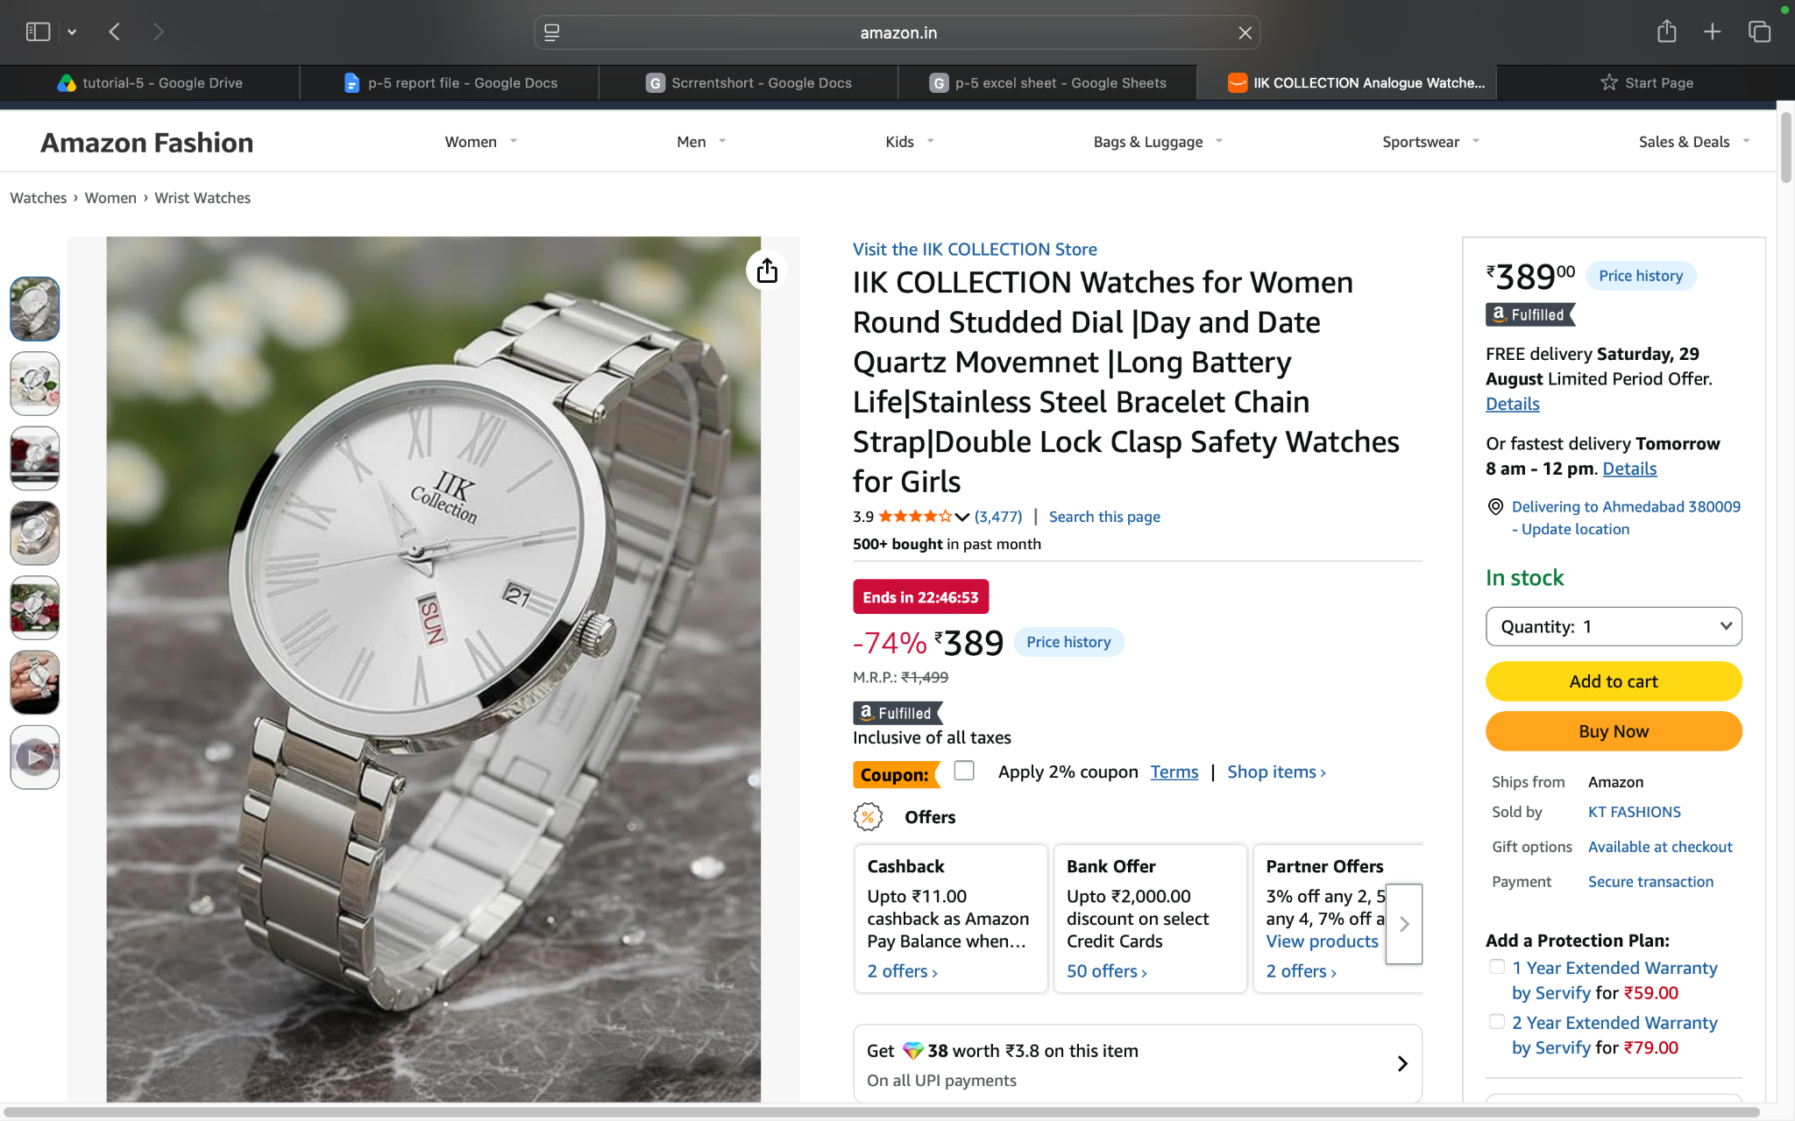

Scenario 1:

Demo login page:amazon product view details
Test Steps:1e
1.amazon product view
2.select product and view
3.check the product details

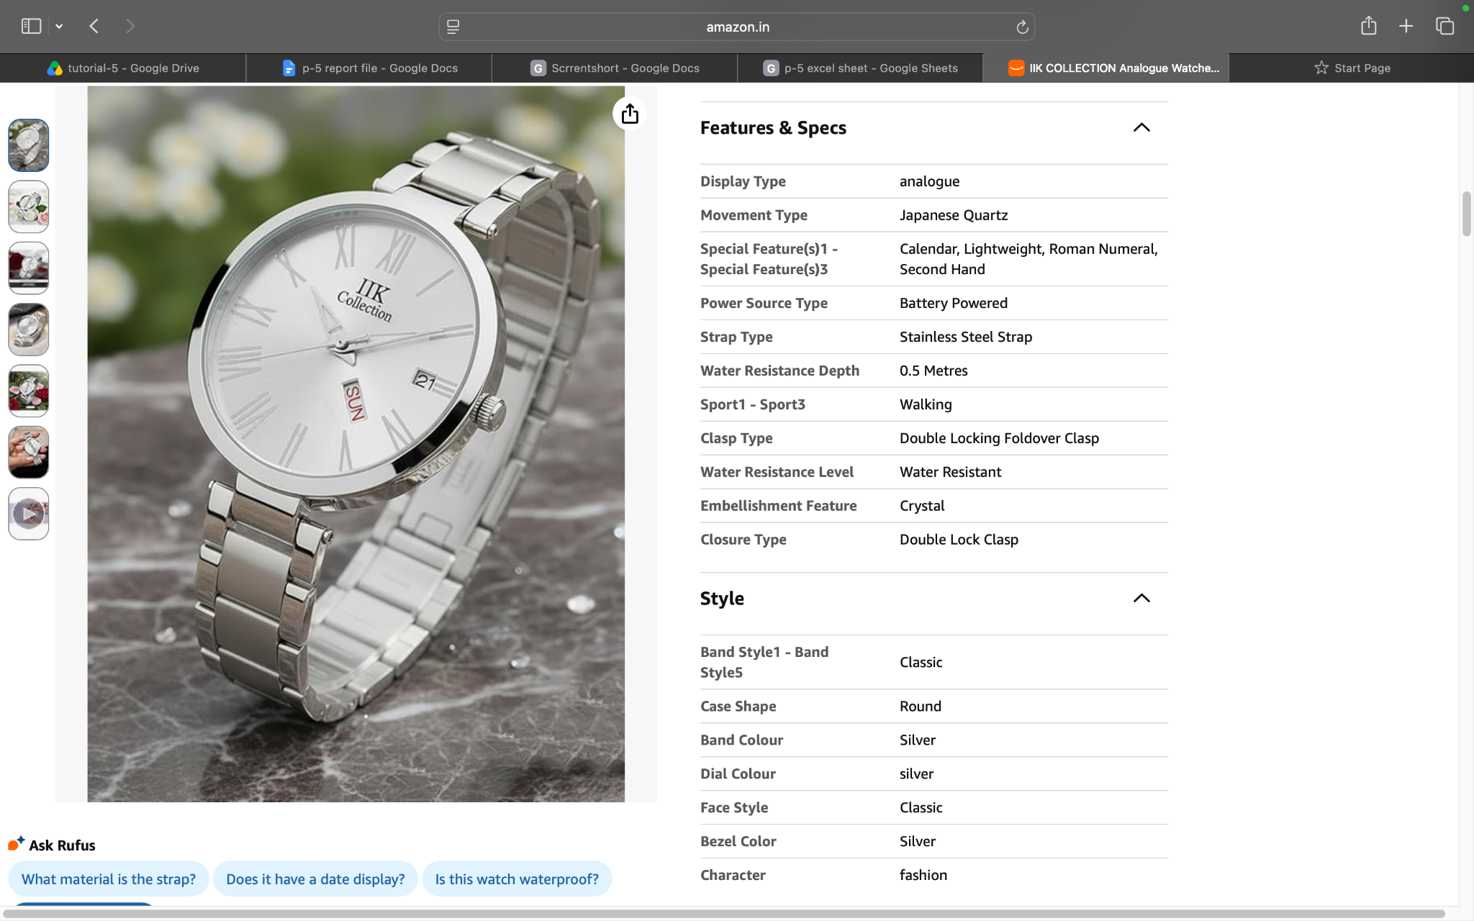

Scenario 1:

Demo login page:amazon product view and add product
Test Steps:1f
1.amazon product view
2.select product and view
3.check the product
4.product add in list

Scenario 2:

Demo login page:amazon product view and open the cart
Test Steps:2a
1.amazon product view
2.select product and view
3.product check in and open the cart
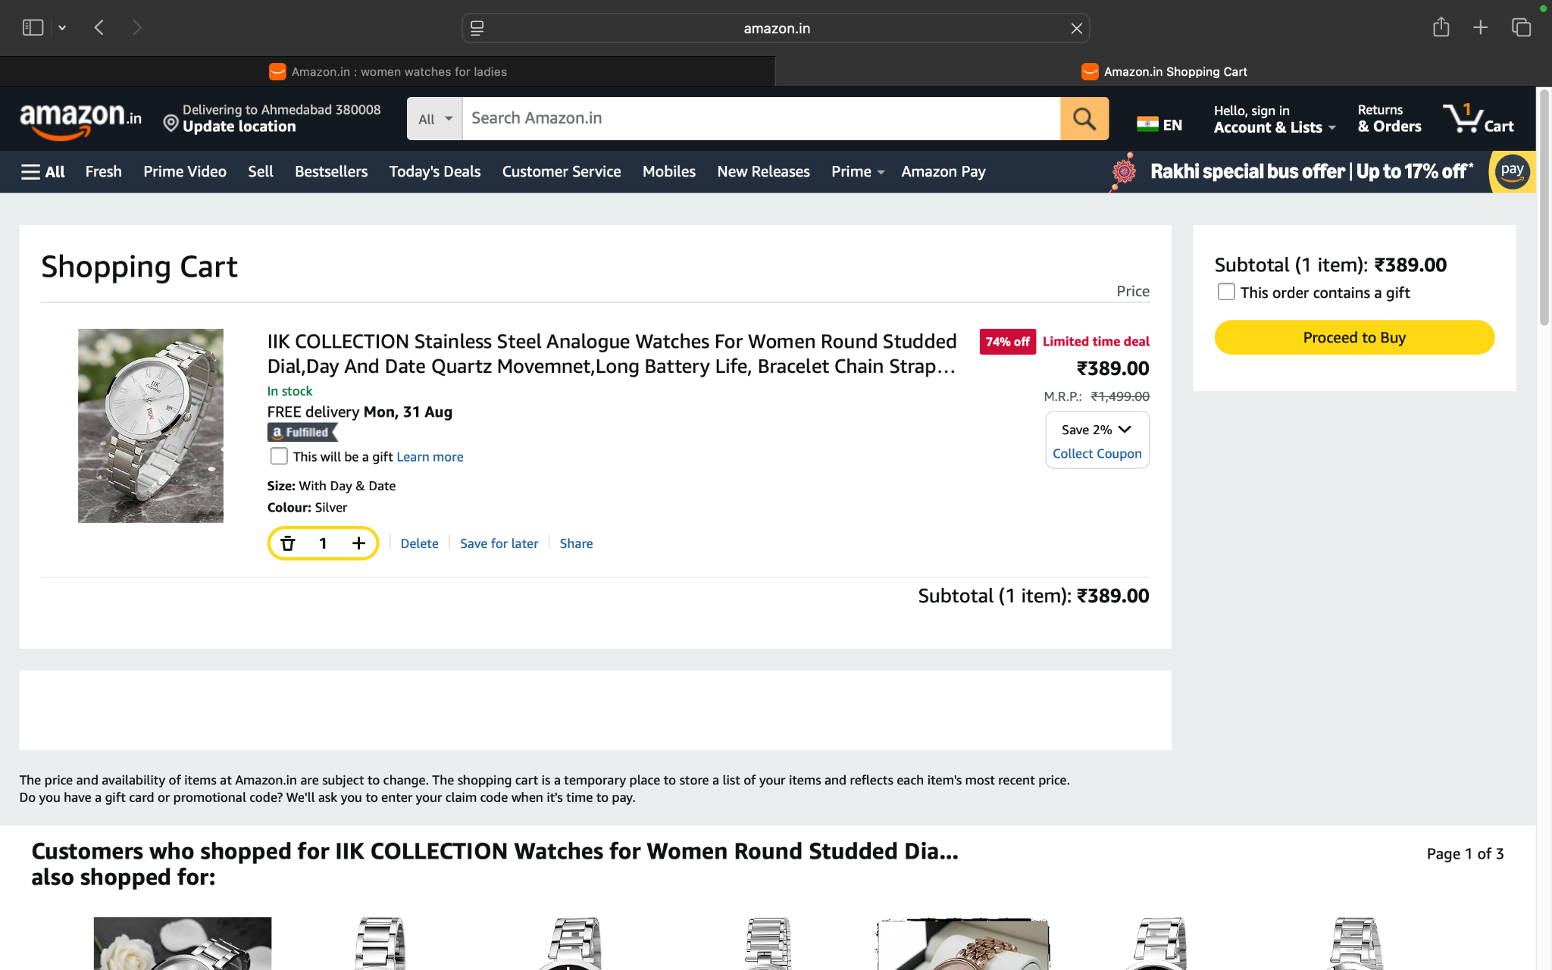

Scenario 2:

Demo login page:amazon product view and verify the cart to product
Test Steps:2b
1.amazon product view
2.select product and view
3.product check in and open the cart
4.verify the product
Scenario 3:

Demo login page:amazon product and remove the cart
Test Steps:3a
1.amazon product view
2.select product and view
3.product check in and open the cart
4.product the remove cart

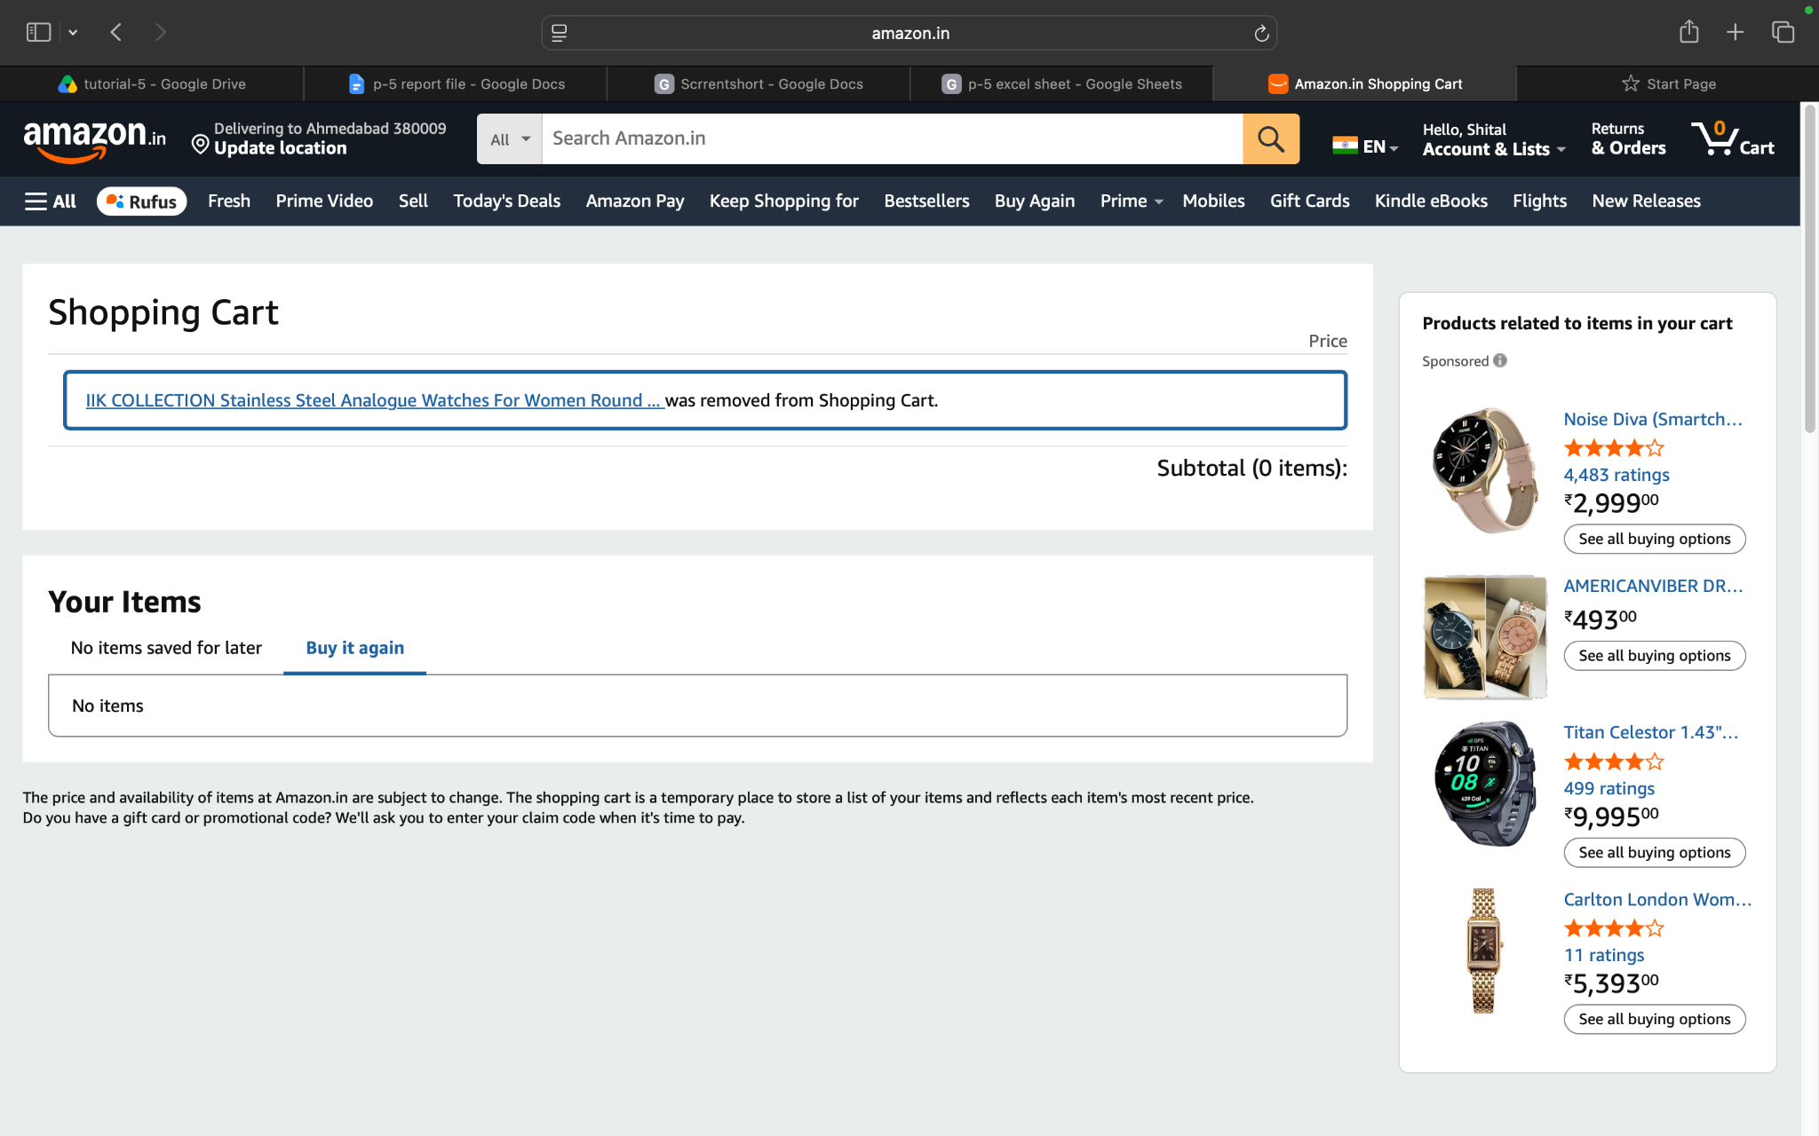
Scenario 3:

Demo login page:amazon logout account
Test Steps:3c
1.amazon product view
2.select product and view
3.product check in and open the cart
4.logout the amazon account

